10 Cls

20 Rem "PROGRAM 19 TO WAP TO GENRATE A TABLE OF VOLUME VS PRESSURE FOR AN IDEAL GAS , USING THE FUNCTION STATEMENT "

22 Print Date$; "AND"; Time$

23 Print "NAME :SAHIL YADAV "

24 Print "ROLL NO. 2131239"

25 Print

30 Input "ENTER THE VALUE BOF NO. OF MOLES "; N

40 Input "ENTER THE VALUE OF TEMPERATURE "; T

Print

Print "TABLE FOR MPRESSURE V/SVOLUME OF IDEAL GAS:"

Print "___________________________________________"

Print "V(L)", "P(atm)"

Print "__________________________________________"

50 For i = 1 To 5

60 Print i, IDEALGAS(N, i, T)

Next i

Print "_______________________________________"

70 Function IDEALGAS (n, v, t)

IDEALGAS = (n * 8.314 * t) / v

80 End Function

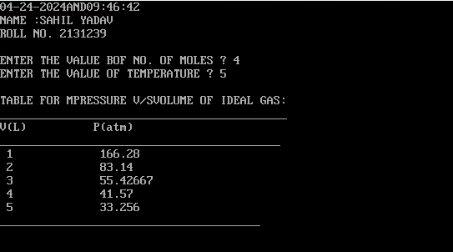

10 Cls

20 Rem "PROGRAM 20 :TO CALCULATE THE COMBINATION "

22 Print Date$; "AND"; Time$

23 Print "NAME :SAHIL YADAV "

24 Print "ROLL NO. 2131239"

25 Print

30 Input "ENTER THE VALUE OF N "; N

40 Input "ENTER THE VALUE OF R "; R

50 Let X = N

60 GoSub 165

70 N1 = P

80 Let X = R

90 GoSub 165

100 N2 = P

110 Let X = N - R

120 GoSub 165

130 N3 = P

140 Let C = N1 / (N2 * N3)

150 Print "C("; N; ","; R; ")="; C

160 End

165 Rem SUBROUTINE

170 P = 1

180 For I = 1 To X

185 Let P = P * I

190 Next I

200 Print P

210 Return

